NOTES:
- Years analyzed: 2000-2024
- Effort is based on the number of interviews from the CREST pull (ie. number of boats)
- Catch is the kept fish and the released fish combined (ie. total catch)
- This data looks only at the region: Alberni Canal (sub-areas 23A and 23B)
  - The relationships can be broken down into sub-areas to see if the relationship changes
- This data looks at Coho only
- The linear model is laid out such that Escapement ~ CPUE
RELATIONSHIP TABLES
R-squared values:
 | 23A | 23B | All sub-areas
AUG | 0.089 | 0.545 | 0.189
SEPT | 0.281 | 0.315 | 0.324
AUG & SEPT | 0.16 | 0.279 | 0.204
Corresponding plots:
 | 23A | 23B | All sub-areas
AUG | 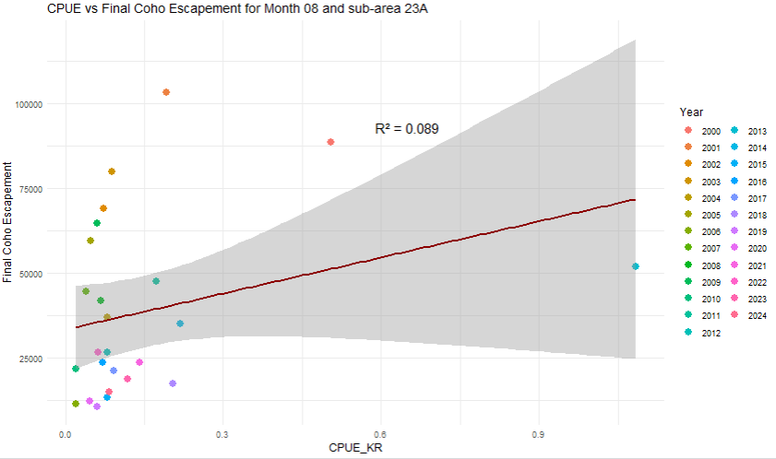 | 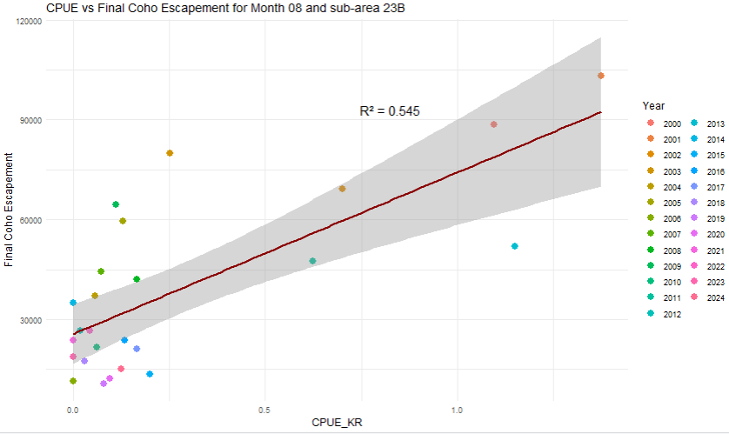 | 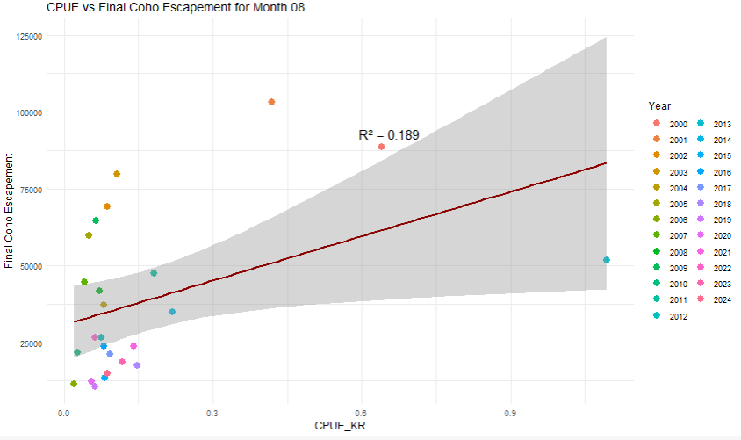
SEPT | 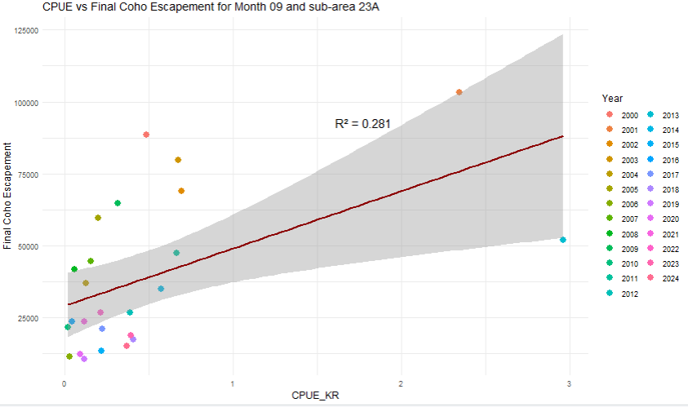 | 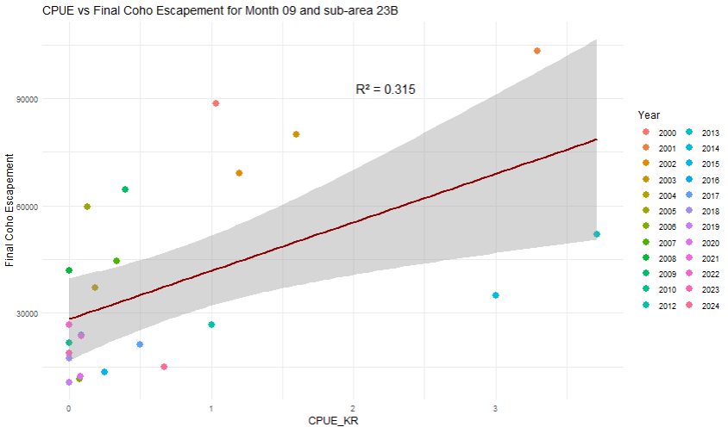 | 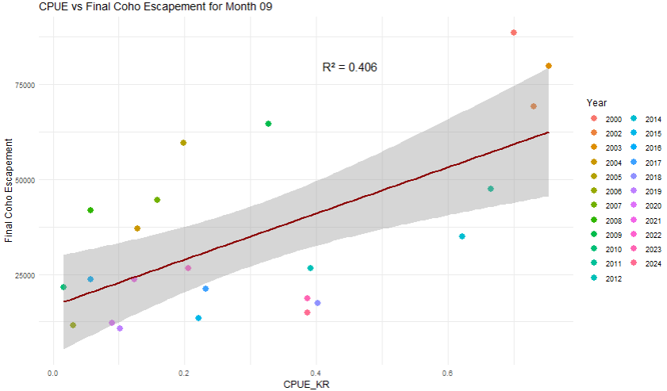
AUG  &  SEPT | 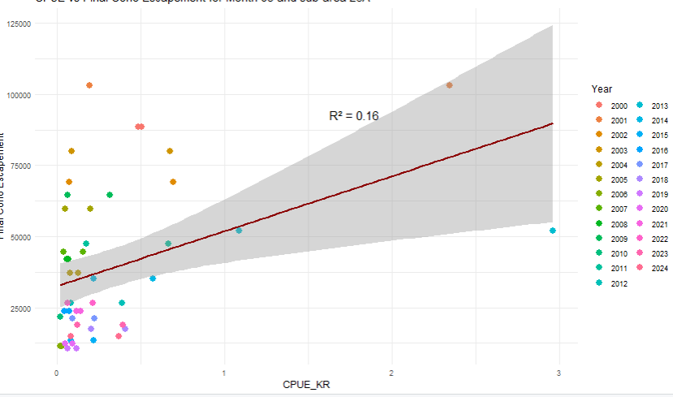 | 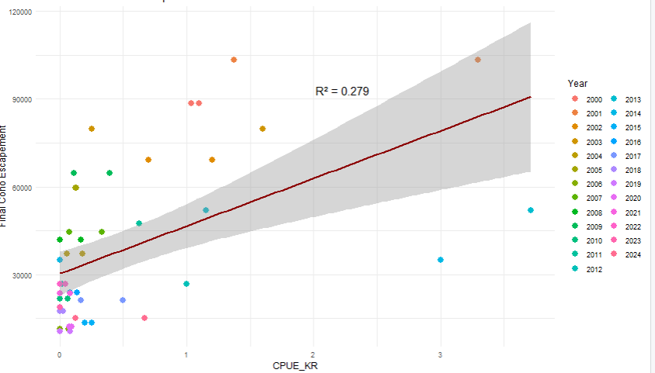 | 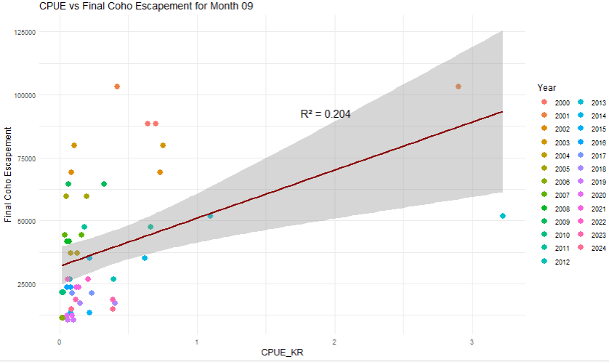

QUARTILE RELATIONSHIP TABLES
R-squared values: (this looks at the total CPUE – not separated into sub-areas)
 | Q1 | Q2 | Q3 | Q4
AUG | 0.054 | 0.313 | 0.571 | 0.002
SEPT | 0.008 | 0.379 | 0 | 0.066
AUG & SEPT | 0.007 | 0.08 | 0.009 | 0.025
Note, these look only at the years that relate to each quartile (2000-2024).

